B.K. Jewellers

**Business Requirement Document (BRD)**

**Document for**

**“Sales management” part.**

Document NO: 001

Date: 07-02-2020

Prepared by:

Group 2

* **Revision History**

|  |  |  |  |
| --- | --- | --- | --- |
| **Revision Number** | **Revision Date** | **Summary of changes** | **Author** |
| **1** | 07/02/2020 | Document made. | Sagar ladva |
| **2** | 18/04/2020 | * **Table of content:** Page numbers added. * **(5):** Processes stock in and out gets combined. * **(8):** Note is updated. | Rudra soni |
| **3** |  |  |  |
|  |  |  |  |

* **Table of Contents** -

|  |  |  |
| --- | --- | --- |
| Sr no. | Content | Page no. |
| 1. | Introduction |  |
|  | 1.1 Purpose | 4 |
|  | 1.2 Scope | 4 |
|  |  |  |
| 2. | General business requirements |  |
|  | 2.1 General requirement | 4 |
|  | 2.2 User characteristics | 5 |
|  |  |  |
| 3. | Business requirement | 5 |
|  |  |  |
| 4. | Use case diagram | 7 |
|  |  |  |
| 5. | Process description | 8 |
|  |  |  |
| 6. | Business data model | 8 |
|  |  |  |
| 7. | Accuracy | 9 |
|  |  |  |
| 8. | Impacts | 9 |

1. **Introduction**
   1. Purpose:

The purpose of making business requirement document is to make transaction of sales easier and the record generation make simple.

* 1. Scope:

The scope of this business requirement document is bounded to only to requirements of “sales department” of **B.K. Jewellers**.

The scope includes:

|  |  |
| --- | --- |
| 1. | Sale activity, |
| 2. | Transfer activity, |
| 3. | Stock-out activity |
| 4. | Sale record maintenance. |

1. **General requirements**
   1. General requirements:

* Only one user on one system.
* Item entry to invoice through barcode scanner.
* Stock transferring.
* Automatic GST applying in invoice.
* A new invoice number generation on every new bill.
* Printing of bills and receipts in pre-defined format automatically.
  1. User characteristics:

|  |  |  |
| --- | --- | --- |
| Name | No. Of user | Responsibility/activity |
| Salesman | 6 | He/she have 50% of computer knowledge and at least 70% of knowledge of rules and regulations of organization. |
| Sales manager | 2 | He/she have 80% of computer knowledge and 95% of knowledge of rules and regulations of organization. |

1. **Business requirement**

|  |  |
| --- | --- |
| 1. | Login |
| Priority | High |
| Originator | Sale merchandise |
| Inputs | Username and password from text fields submit and reset from a button. |
| Operations | When username and password is added, values will validate. |
| Outputs | If successful, user will navigated into software else the text fields will become red. |
| Error handling | If the inputted data is incorrect it will show an alert message “username and password is wrong!!”. |
| User need | User needs this for login to the software. |
| Benefits | First level of security to access the software. |

|  |  |
| --- | --- |
| 2. | Sale Invoice |
| Priority | High |
| Originator | Sale merchandise |
| Inputs | Adding items through barcode scanner or by text fields.  Text field for GST and extra charges. |
| Operations | When item is added, finding all related information of it from database.  Automatic GST charges apply for particular item. |
| Outputs | Display the details of item in invoice.  Final price calculated. |
| Error handling | If the data can’t be fetched, the respective input fields will fill up with dashed line and an alert message pops up “Unable to fetch data!!”. |
| User need | User needs this requirement for making invoices. |
| Benefits | Fewer efforts for tax calculation.  Single input and multiple outputs. |

|  |  |
| --- | --- |
| 3. | Transfer |
| Priority | High |
| Originator | Sale merchandise |
| Inputs | Adding items through barcode scanner or by text fields. |
| Operations | When item is added, finding all related information of it from database. |
| Outputs | Display the details of item in receipt.  Total number of items. |
| Error handling | If the data can’t be fetched, an alert message pops up “Unable to fetch data!!”. |
| User need | User needs this requirement to transfer items from one branch to other or outside of organization for presentation purposes. |
| Benefits | Fewer efforts to track the item location. |

1. **Use case diagram**

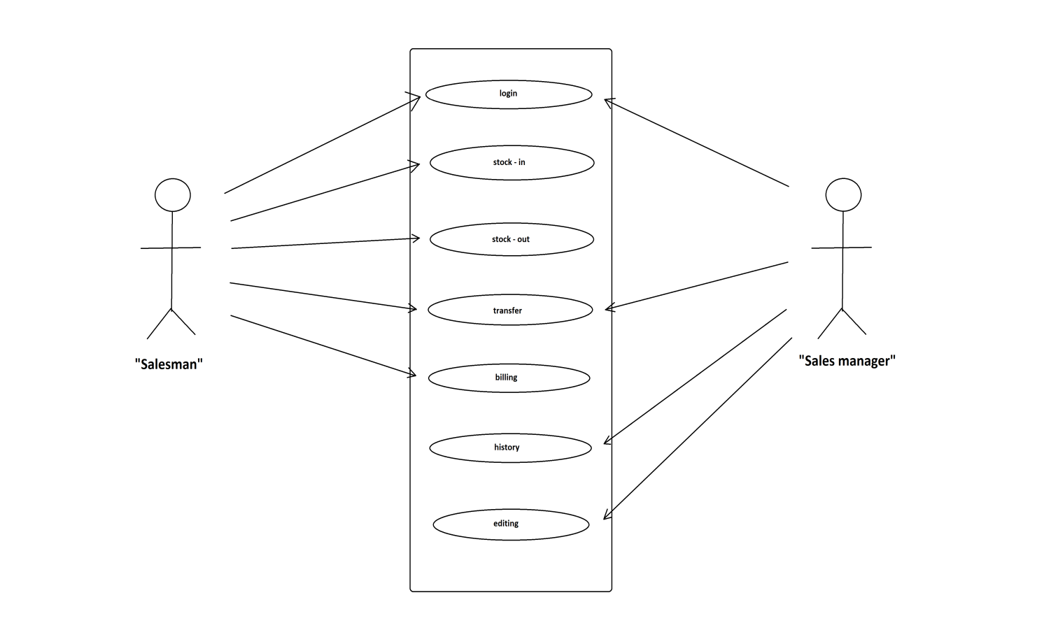

|  |  |
| --- | --- |
|  | Indicates software. |
|  | Indicates modules. |
|  | Indicates access/rights. |
|  | Indicates users. |

1. **Process description**

|  |  |
| --- | --- |
| Details | Process Description |
| Process Name | Login |
| Purpose | It should be the first process for entering to software. |
| priority | High |
| Frequency/Duration | Login process should not more than 2seconds to complete and navigate the user to the main page of the software. |

|  |  |
| --- | --- |
| Details | Process Description |
| Process Name | Stock in/out. |
| Purpose | It should be the process done for any movement of items within (branches) and outside (exhibitions, in-house presentation) of organization. |
| priority | High |
| Frequency/Duration | This process will take time, if there are many entries but after the completion of adding items it should take 3seonds to register. Print the details of items on a receipt. |

1. **Business data model**

**---------(N/A)---------**

Note: insufficient knowledge.

1. **Accuracy**

The accuracy will always be higher in any of the functions which can be done by the software even in printing the invoices.

All the automatic processes will be completed with very high level of accuracy in the results generated by them.

1. **Impacts**

**---------(N/A)---------**

Note: Software is being made first time.